Letter of Intent Form – Team Information

Due October 15, 2021, by 4pm. Submit to: education.award@vch.ca

The Knowledge Translation (KT) Challenge is designed to support teams of PHC, VCH and BC Cancer clinicians who want to move evidence into practice. The KT Challenge is run in partnership with Providence Health Care Professional Practice, Providence Health Care Research Institute, Vancouver Coastal Health Research Institute (VCHRI), VCH Professional Practice, and the BC Cancer Department of Nursing and Allied Health Research and KT, and is supported by funding from PHC, PHCRI, VCHRI, BC Cancer, and Transplant Research Foundation.

Project Title:
Team Lead Information
Name: Click here to enter text. | Position/Title: Click here to enter text.
Email: Click here to enter text. | Phone (work): Click here to enter text.
Site/Unit: Click here to enter text. | Signature*:
Team Members’ Information
Name #1: Click here to enter text. | Position/Title: Click here to enter text.
Email: Click here to enter text. | Phone (work): Click here to enter text.
Site/Unit: Click here to enter text. | Signature*:
Name #2: Click here to enter text. | Position/Title: Click here to enter text.
Email: Click here to enter text. | Phone (work): Click here to enter text.
Site/Unit: Click here to enter text. | Signature*:
Name #3: Click here to enter text. | Position/Title: Click here to enter text.
Email: Click here to enter text. | Phone (work): Click here to enter text.
Site/Unit: Click here to enter text. | Signature*:
*By signing above, you agree to communicate with the organizing committee any changes to your team or your participation, to complete the online KT Challenge evaluation surveys and to encourage all your team members to complete the surveys.
Manager Support
By signing, I acknowledge that I have discussed this practice change with the team leader and agree to support them in this project. If this project is funded I will work with the team members to accommodate requests for scheduled time to work on this project.
Manager Name: Click here to enter text. |  | Position/Title: Click here to enter text.
Email: Click here to enter text. |  | Signature:
Agreement between Team Members and KT Challenge Organizing Committee
If you are accepted for participation in the KT Challenge, the organizing committee agrees to work with you to select a mentor for your project and provide KT skills workshops. If your project is funded, we will support you to conduct your KT project.

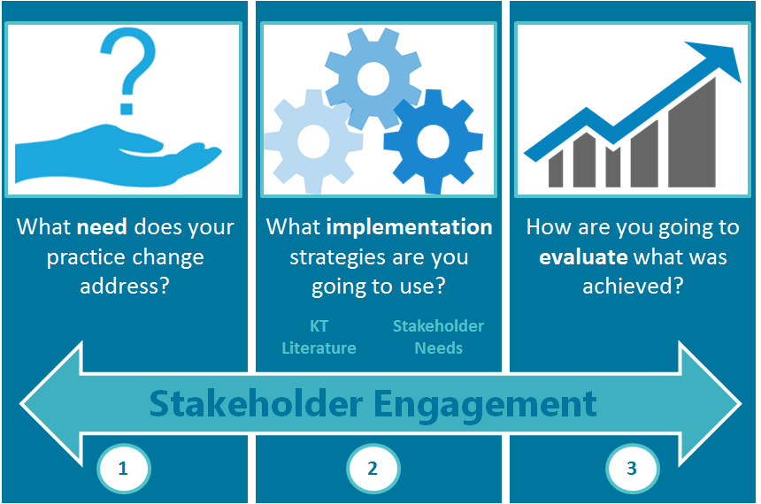

To begin the application process, please complete and submit this LOI by 4 pm October 15, 2021. Virtual Workshop #1 (December 10, 2021) and Virtual Workshop #2 (March 7, 2022), will help you prepare the full application for funding in the KT Challenge, due April 29, 2022.

Application Form – Section 1

Describe the practice change you would like to implement and briefly present the evidence that shows that this change will bring value to your area of practice. (250-word maximum)
Please make sure to:

- Select a short and informative title for your project.
- Clearly and succinctly describe the practice change you wish to implement (e.g., “we are going to implement a palliative approach with all patients in one unit”; OR, “we are going to conduct a medication management assessment on all patients at intake in one hospital”; OR, “we are going to implement the use of a validated screening tool for depression for all cardiac patients in one hospital.”)
- Briefly explain the need or impetus for this practice change citing evidence from the location where this practice change will take place (e.g., Though harm reduction practices have been supported and implemented in acute psychiatry, concerns over utilization continue to be observed and expressed (PHC, 2019). Chart audits show that less than 20% of patients receive information on harm reduction and 49% of staff report not feeling confident in engaging patients in harm reduction conversations.
- Provide a brief overview of the evidence-base for the practice change (i.e., the published research or evidence that shows your practice change will effectively address the need you have identified). For example, you might say, “The Canadian Pediatric Association developed a guideline for skin-to-skin contact during invasive procedures in 2017. This guideline has not been implemented in our NICU and this practice chance will support the implementation of this guideline. Evidence shows that skin-to-skin contact during invasive procedures results in less stress for infants and parents and more favourable outcomes.”

Submit this LOI by October 15, 2021 at 4:00pm, to: education.award@vch.ca

Note: This Letter of Intent will be reviewed by the KT Challenge Advisory Committee and you may receive feedback.

